1. What is true for Composite pattern?

* **Clients can treat part and whole objects uniformly.**
* There can be only one Leaf implementation
* Composite has a limit on number of Leafs it can contain
* Composite pattern cannot support tree structure

1. The following high-level GoF description defines the ____________ design pattern

... is a design pattern that allows a group of interchangeable, similarly structured, multi-step algorithms to be defined. Each algorithm follows the same series of actions but provides a different implementation of the steps.

* **Template Method**
* Strategy
* Abstract Class
* Visitor

1. What is true for the following Visitor UML Diagram?

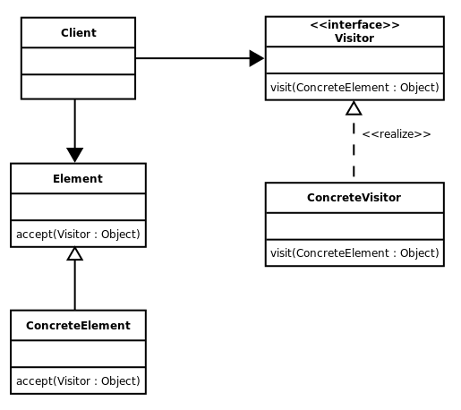

* ConcreteElement has to accept ConcreteVisitor
* Element hast to contain "visit" and Visitor "accept" method
* Element should be renamed to Subject
* **UML is valid**

1. The following implementation is part of which sub-component of the Command pattern?



* Concrete Command
* **Receiver**
* Invoker
* Client

1. The Command interface could be an interface or an abstract class

* **True**
* False

1. The _______________ decouples the execution of the commands from the client

* Command Interface
* Concrete Command
* **Invoker**
* Receiver